|  |
| --- |
| **Church News**  Prayer Meetings  Congregational prayer meetings next Sunday before Kingsgrove and Bankstown services (10am and 3pm).  BLAST Supporter’s Night  Bankstown Local Area Scripture Team Supper - June 2, 7pm at 122 Waterloo Rd Greenacre.  Come and hear about what God is doing in the south-west in our local high schools.  Support Gospel work at SWEC!  Generous financial partners are needed to help grow the ministry of Gospel work at SWEC.  Please consider partnering with SWEC by setting up electronic giving.  For information on how to set this up, email [give@swec.org.au](mailto:give@swec.org.au)  Community Groups  Want to know how your faith in Jesus interacts with your everyday life? Community groups are a great place to help you think through this. Meeting throughout the week on a regular basis, community groups are a great opportunity to help make sense of what it means to be a believer of Jesus in this world. For more information please email [communitygroups@swec.org.au](mailto:community@swec.org.au) |

|  |  |  |  |  |  |  |  |
| --- | --- | --- | --- | --- | --- | --- | --- |
| **Upcoming Events**  June  2 – BLAST Info Supper  3 – Congregational prayer meeting  17 – Church lunch  July  18 – Combined Prayer and Worship Night (7.45pm Kingsgrove) | **Stay Connected**   |  |  | | --- | --- | |  | fb.com/swechurch | |  | @swechurch | |  | swec.org.au/newsletter | |

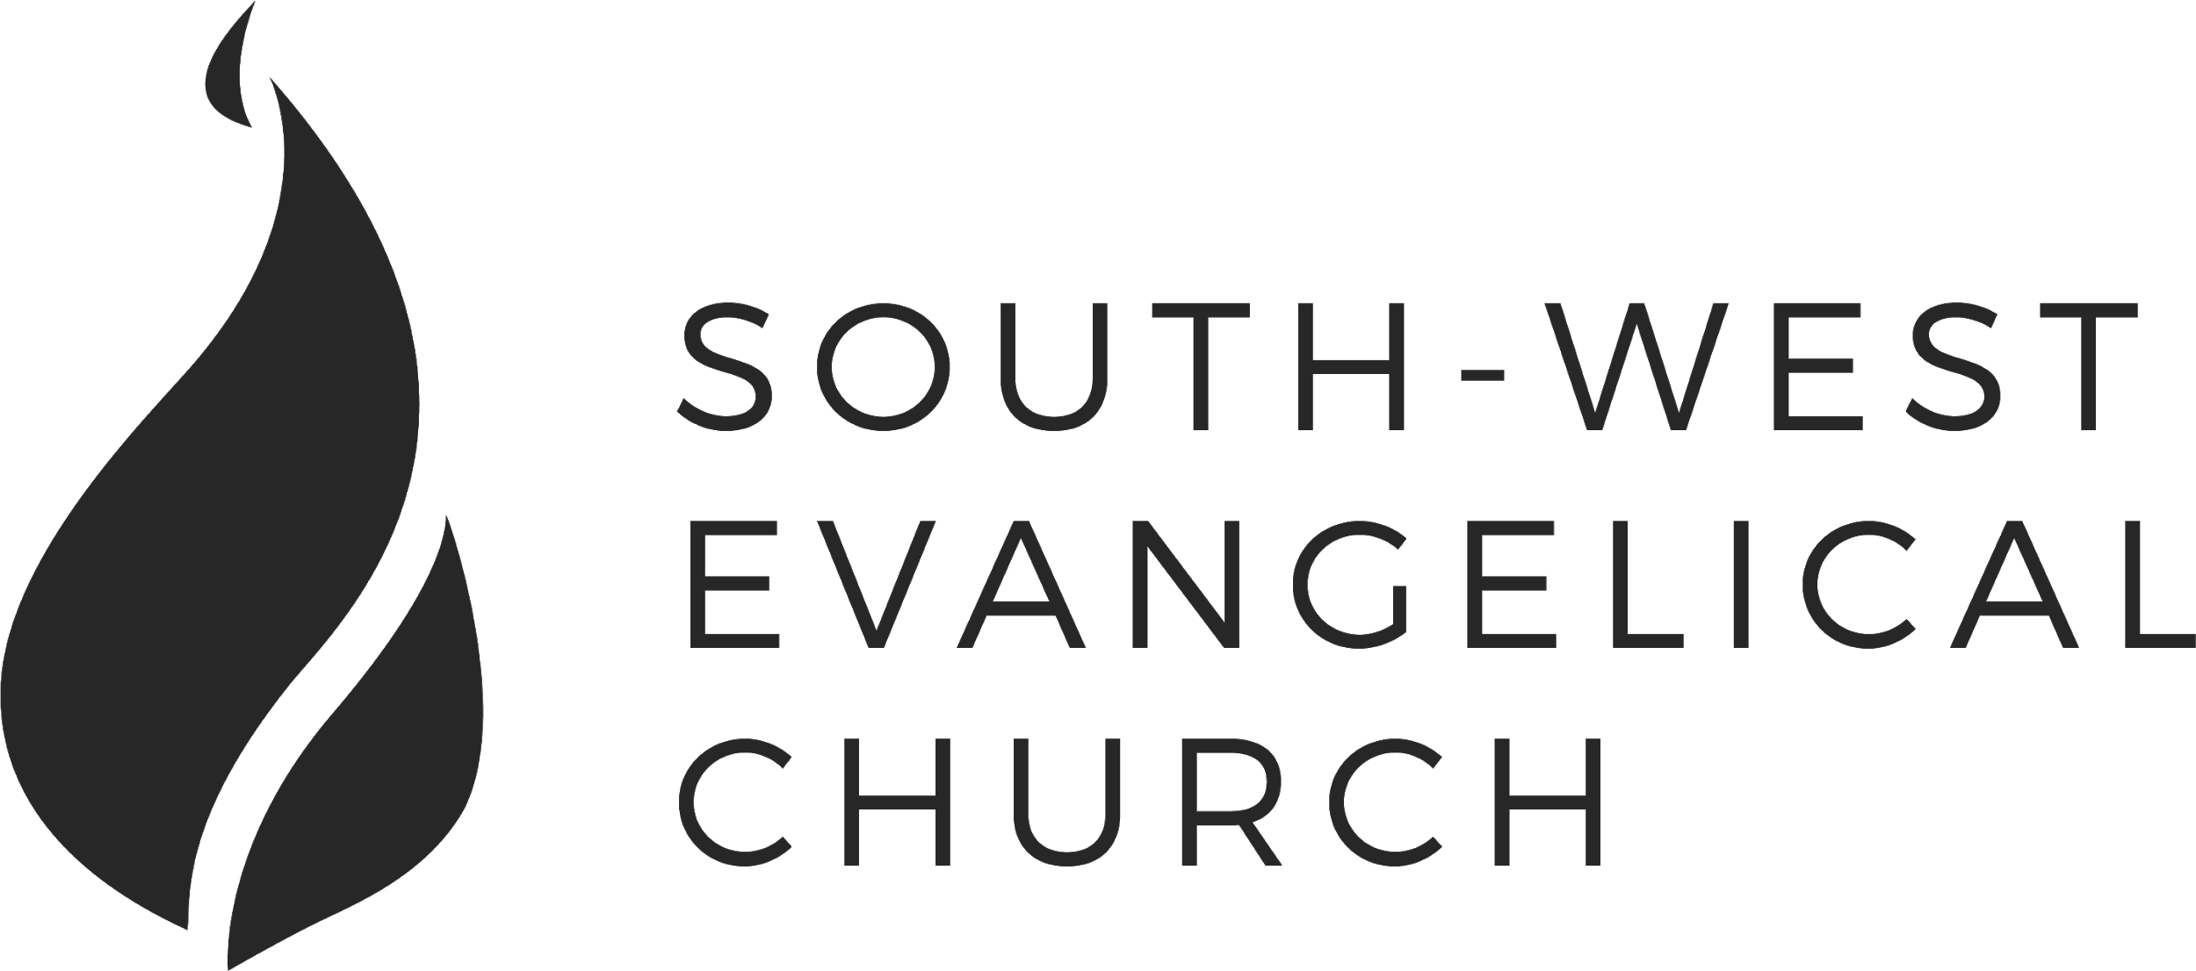

Sunday, 27 May 2018 | Kingsgrove 11am Service | [www.swec.org.au](http://www.swec.org.au)

Pastor Peter Ko | 0433 493 488 | pko@swec.org.au

What we’ll be doing during our time together

1. Worship

We’ll be worshipping God through song, prayer and by hearing His word.

Today’s confession prayer

Merciful God, our maker and our judge, we have sinned against you in thought, word, and deed:  
we have not loved you with our whole heart, we have not loved our neighbours as ourselves:  
we repent, and are sorry for all our sins.  
Father, forgive us.  
Strengthen us to love and obey you in newness of life;  
through Jesus Christ our Lord.  
Amen

Bible reading - Joshua 1:1-2, 5-9

2. Community

An opportunity to get updated with what’s happening at SWEC!

3. Prayer

We’ll be praying for various needs in our church, the wider community, and the world.

4. God’s Word

Today’s sermon will be will be given by Dom Cheung.

5. Response

An opportunity for us to respond by singing, through holy communion, and by financial giving.

6. Blessing & Sending  
Go with God’s blessing to love and serve him and the world.

|  |  |  |
| --- | --- | --- |
| **Pastors**  Peter Ko (Lead Pastor)  Stephen Fei  Dom Cheung  Karen Ko | **Elders**  Johnson Lee  Andrew Lim  Kirby Wong  Nelson Siu  board@swec.org.au | **Student Pastors**  Andrew Hayes  James Hoey  **Ministry Intern**  Lisa Truong |

'De-priest-ciated'

Numbers 16:1-3

Introduction

1. Two 'Accusations'
2. Two Responses
3. What do we learn

Today’s Sermon Code: LKZ

Zacpages is a digital church tool to follow our sermon outlines, read bible references, take notes and find out more information about our upcoming church events.

Check it out on the Apple App Store, or Google Play Store!

